Police Body Cameras
(Excerpted from CRF’s Bill of Rights in Action, 31:2)

Being a police officer is a dangerous job. Officers make arrests, respond to calls, deal with criminal suspects, and even intervene in crimes in progress. A seemingly harmless situation — walking around the corner on a street, pulling over a motorist — can turn perilous, even deadly, in an instant.

In recent years there has been more coverage on the news of situations where police have used force in making arrests, and sometimes the use-of-force has been deadly. In many cases, the media has received video of these events taken by onlookers. In some cases, video of these events has been taken by officers who have body or car cameras on the scene.

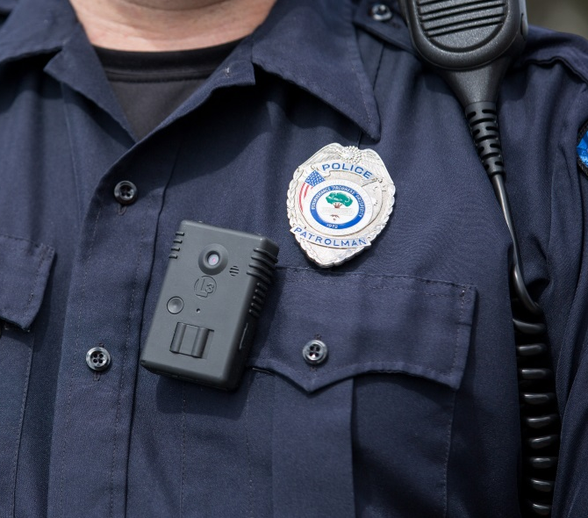
Many police departments have started to equip their officers with body cameras to record what happens in an incident. The cameras are worn on the officer’s uniform and cost only several hundred dollars each.

Supporters of putting body cameras on police officers argue that video eliminates much of the uncertainty of what happened, as in the shooting of Michael Brown in Ferguson, which was not caught on video. Video can be used as evidence at trials where eyewitness accounts often differ. Video can also be used for training recruits and disciplining officers who violate department policy. In addition, body-camera video can defuse false rumors of police misconduct and build community trust by recording the difficult decisions police have to make throughout the day.

Critics of body cameras counter that they are totally under the control of the officer who decides when to turn it on and off. Others voice privacy concerns such as recording statements of a child, a rape victim, or a witness who fears retaliation from a gang. Some argue that body cameras might even erode community trust if footage is made public of people in private moments of grief or anguish at a crime scene. Body cameras show only one narrow view, say the critics, and do not show entirely what the officer is doing. Some are troubled that this is another step in the widespread government surveillance of Americans.

Little research has been conducted on the use of body cameras. The most noted study was done in 2012–13 in Rialto, Calif., with a police force of about 50 officers. It showed a 60-percent drop in use of force by the half of the police department that wore body cameras. Citizen complaints also fell by almost 90 percent.

The results of a study done in San Diego, Calif., in 2014–15 were more mixed. Citizen complaints fell by 23 percent, but use of force increased 10 percent. The study also revealed an 8-percent drop in the use of alternative control methods like pepper spray and stun guns, which some view as less dangerous than the use of firearms. The researchers called for caution in adopting body cameras until more studies have been done.

In 2015, Los Angeles became the largest city in the U.S. to adopt body cameras for its entire police force of 7,000 officers. But disagreement has erupted over the body-camera usage rules.

The most controversial issue was over the rule that required officers to view the video of their use-of-force incidents before writing their reports. Police officials said that viewing the video first will make sure officers write complete and accurate reports while deterring dishonesty. But those who opposed this rule argued that it gives officers a chance to shape their written reports to their advantage, leaving out important details not shown in the video.

Another controversy arose over who should have access to police body-camera video. The Los Angeles Police Department policy prohibits releasing video to the public unless authorized by the chief. The purpose of this rule is to observe privacy laws and control evidence. Critics of this rule, however, called for public release of video involving alleged police misconduct.

Discussion Question:

Do you think police body cameras are a good idea or not? Why?

Graphic: https://commons.wikimedia.org/wiki/File:Bodycam-north-charleston-police.jpg

