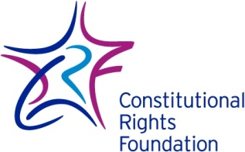
The Meeting at Runnymede

King John of England inherited his crown from his brother Richard I. Unlike his brother, John was not popular. He quarreled with the Pope, collected high taxes, and angered the English nobility. The barons resented the high taxes he imposed and his demands on them to furnish soldiers for wars in France. Eventually, the barons broke their allegiance to the King John. They also formed an army to challenge him. The king was in a position of weakness. Most of King John’s fighting men were scattered throughout his kingdom. The rebels held London, the capital of England and appeared at full military strength.

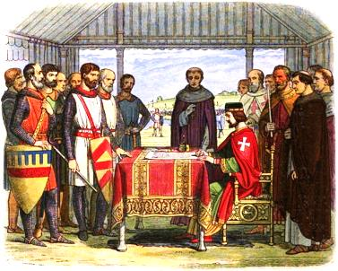
King John and his supporters, the rebel barons, and Archbishop of England, Stephen Langton all met at Runnymede on June 15, 1215. Little is known about the details of this historic meeting. We do know that King John agreed to a document called the “Articles of the Barons.” Over the next few days, these articles were rewritten, expanded, and put into the legal language of a royal charter.
King John Signs the Magna Carta

Around June 19, King John put his seal on the final draft of what we call today the Magna Carta, or Great Charter. In exchange, the rebellious barons renewed their oath of allegiance to King John, ending the immediate threat of civil war.

Written in Latin, the Magna Carta consisted of 63 articles, or chapters. Many concerned matters of feudal law important to the rebel barons. Other parts of the Magna Carta corrected King John’s abuses of power against the barons, church officials, merchants, and other “free men” who together made up about 25 percent of England’s population. The Magna Carta virtually ignored the remaining 75 percent of the population (serfs and women).

For people today, the most significant part of the Magna Carta is chapter 39:
No free man shall be arrested or imprisoned or disseised [property taken] or outlawed or exiled or in any way victimized, neither will we attack him or send anyone to attack him, except by the lawful judgment of his peers or by the law of the land.

The purpose of this chapter was to prevent King John from personally ordering the arrest and punishment of a free man without a lawful judgment. According to the Magna Carta, “lawful judgment” could only be made by judges ruled by “the law of the land,” or by one’s peers in a trial by combat.

The Magna Carta of 1215 was not really intended to be a list of rights for Englishmen or even the barons themselves. It was more like a contract.

John agreed to follow its provisions. The barons only wanted King John to satisfy their complaints against his abusive rule, not overthrow the monarchy. The real significance of this document lies in the basic idea that a ruler, just like everyone else, is subject to the rule of law. When King John agreed to the Magna Carta, he admitted that the law was above the king’s will, a revolutionary idea in 1215.

Aftermath
King John surrendered significant power when he agreed to the Magna Carta. It is doubtful that he really ever intended to live up to all his promises. He secretly wrote the pope asking him to cancel the Magna Carta on the grounds that he signed it against his will. John continued to build up his mercenary army. Not trusting John’s intentions, the rebel barons held on to London and maintained their own army.
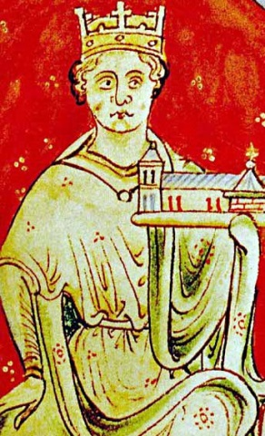
Pope Innocent III replied favorably to King John’s appeal. He condemned the Magna Carta and declared it null and void. By September 1215, King John and his army were roving the countryside attacking the castles of individual barons, but he avoided the rebel stronghold of London. The barons charged that King John had defaulted on his agreement with them and they were justified in removing him from the throne. They offered the throne to the son of the French king if he would aid their rebellion.

A long and bloody civil war loomed across England when suddenly King John died. A round of heavy eating and drinking apparently led to a case of dysentery causing his death on October 18, 1216. Ten days later, John’s 9-year-old son, Henry, was crowned as the new king of England. With John out of the way, the conflict gradually ended. Less than a month after Henry was crowned, his supporters confirmed the Magna Carta in his name. This time it received the approval of the pope.
King John holding a church.

The Magna Carta, carrying with it the idea of “the rule of law,” was reconfirmed a number of times over the next 80 years, becoming a foundation of English law. Eventually, the Magna Carta would become the source of important legal concepts found in our American Constitution and Bill of Rights. Among these are the right to a fair trial under law and the principle that everyone, even important officials, must obey the law.

These foundations of our own constitutional system had their beginnings in a meadow beside a river almost 800 years ago.

For Discussion

- Do you agree or disagree with King John’s argument that the Magna Carta was not valid? Why?

- Why is the “rule of law” important for a democracy?

- What are the most important ideas from the Magna Carta for American democracy today?

Graphic: King John Signs the Magna Carta.
Doyle, James William Edmund (1864) "John" in A Chronicle of England: B.C. 55 – A.D. 1485, London: Longman, Green, Longman, Roberts & Green, pp. p. 226
https://commons.wikimedia.org/wiki/File%3AA_Chronicle_of_England_-_Page_226_-_John_Signs_the_Great_Charter.jpg

Graphic: King John holding a church, painted c.1250–59 by Matthew Paris https://en.wikipedia.org/wiki/Magna_Carta#/media/File:John_of_England_(John_Lackland).jpg

