English-Language Arts: Operational

Lesson Title: The Meaning of the Federalist Papers

Enduring Understanding: Equality is necessary for democracy to thrive.

Essential Question: How did the constitutional system described in The Federalist Papers contribute to our national ideas about equality?

Lesson Overview
This two-part lesson explores the Federalist Papers. First, students engage in a discussion about how they get information about current issues. Next, they read a short history of the Federalist Papers and work in small groups to closely examine the text. Then, student pairs analyze primary source manuscripts concerning the Federalist Papers and relate these documents to what they have already learned. In an optional interactive activity, students now work in small groups to research a Federalist or Anti-Federalist and role-play this person in a classroom debate on the adoption of the Constitution. Extended writing and primary source activities follow that allow students to use their understanding of the history and significance of the Federalist Papers.

Lesson Objectives

Students will be able to:

- Explain arguments for the necessity of a Constitution and a bill of rights.
- Define democracy and republic and explain James Madison’s use of these terms.
- Describe the political philosophy underpinning the Constitution as specified in the Federalist Papers using primary source examples.
- Discuss and defend the ideas of the leading Federalists and Anti-Federalists on several issues in a classroom role-play debate. (Optional Activity)
- Develop critical thinking, writing skills, and facility with textual evidence by examining the strengths of either Federalism or Anti-Federalism. (Optional/Extended Activities)
- Use both research skills and creative writing techniques to draft a dialogue between two contemporary figures that reflects differences in Federalist and Anti-Federalist philosophies. (Optional/Extended Activities)

Lesson Materials

Part I Textual Analysis and Discussion

• Handout A: Background to The Federalist Papers with questions for Discussion and Writing

Part II Primary Source Analysis and Discussion
• Handout B1: Text of “[Alexander Hamilton]. Number LXVIII.” (Federalist No. 68)
• Handout B2: Text of “[Elbridge Gerry’s Reasons for Not Signing the Federal Constitution]”
• Handout C1: Source Analysis Questions for “[Alexander Hamilton]. Number LXVIII.”
• Handout C2: Source Analysis Questions for “[Elbridge Gerry’s Reasons for Not Signing the Federal Constitution]”

Optional/Extended Activity Handouts
- Handout D: Short Biographies
- Handout E: Debate: Federalist vs. Anti-Federalist
- Handout F1: Alexander Hamilton to George Washington [Farrand’s Records—LIV]
- Handout F2: James Madison to George Washington [Letters of Delegates to Congress]
- Handout G: Objections of the Hon. George Mason {Elliot’s Debates, Volume I]

Sources
Part I Textual Analysis and Discussion
- “Title page of The Federalist, vol. 1.” https://www.loc.gov/item/2003654698/
- “The Foundation of American Government / Hy. Hintermeister.” https://www.loc.gov/rr/program/bib/ourdocs/Constitution.html

Part II Primary Source Analysis and Discussion
- “[Alexander Hamilton]. Number LXVIII.” http://www.loc.gov/exhibits/creating-the-united-states/convention-and-ratification.html#obj16
- Elbridge Gerry’s Reasons for Not Signing the Federal Constitution.. http://www.loc.gov/teachers/classroommaterials/presentationsandactivities/presentations/timeline/newnatn/usconst/egerry.html

Optional Classroom Debate/Optional Primary Source Activity
- Patrick Henry https://www.loc.gov/resource/det.4a26886/
- Alexander Hamilton https://www.loc.gov/resource/det.4a26168/
- George Mason http://memory.loc.gov/cgi-bin/query/h?ammem/fawbib:@field(NUMBER+@band(icufaw+apc0009))
- James Madison https://www.loc.gov/item/2016712636/
- Richard Henry Lee https://www.loc.gov/rr/program/bib/ourdocs/leeresolution.html
- John Jay https://www.loc.gov/item/today-in-history/december-12
- Alexander Hamilton to George Washington
- James Madison to George Washington
- Objections of the Honorable George Mason

Lesson Preparation
You might arrange time for students to do research in the library or in the computer lab.
Provide students with the following vocabulary terms to define prior to the lesson:
Amendment | Revolutionary War
Delegates | Constitution
Independence | Philadelphia
separation of powers | government

Lesson Implementation

Part I Textual Analysis and Discussion
- Focus Discussion
To help students understand that public issues are still debated in the media (as they were debated when the essays appearing in the Federalist Papers were written), engage students in a brief discussion about how we get information on political issues today. Questions to raise:
What is meant by the term “political” or “public” issue?
ANSWER: Students should be able to explain that governmental, social, and cultural topics can have national interest. For example, public figures might express political opinions on Twitter that become controversial and newsworthy.
What are some of the most hotly debated political issues today?
ANSWER: Students should mention current issues. Accept reasonable responses.
How can you find out about these issues?
ANSWER: From school, parents, friends, the media (television, radio, newspapers, magazines), the Internet, and social media.
What do you think is the best way to get reliable information on these issues? Why?
ANSWER: Accept any reasoned response. Look for students suggesting sources that present balanced and accurate views of controversies, or the pros and cons of issues.

- Pre-Reading: The Federalist Papers
- Link the previous focus activity to the Federalist Papers by explaining that even our Constitution was once an object of intense political debate. Give students the following background:
During the Revolutionary War, the colonists had to set up a new government. The first government was set up under the Articles of Confederation. This document created a weak government. This was what Americans wanted because of their experiences with the British government. They wanted a government that would not take away their freedom. But the government under the Articles of Confederation was too weak. So delegates met in Philadelphia at the Constitutional Convention. They wrote a new Constitution that created a stronger government. People at the time debated whether the Constitution should be adopted. Much of this debate took place in the newspapers. Two delegates from the Continental Convention, Alexander Hamilton and James Madison, and diplomat John Jay wrote articles in New York newspapers favoring the Constitution. These articles were later published in book form and called the Federalist Papers.

- Tell students that they are going to read about the Federalist Papers. As they read, they need to look for:
  - Why historians and other people today think the Federalist Papers is so important.
  - Two key ideas about our Constitution and government that the Federalist Papers explains.
- Distribute Handout A: The Federalist Papers to each student and explain that, after they read, they will examine and discuss the key ideas in the Federalist Papers to learn why this document is considered so important. (Students may read Handout A for homework.)
- Small-Group Activity: Examining the Text
This activity is a significant preparatory step designed to fully engage students in the background reading on the Federalist Papers (Handout A). The work that students do here should lead to a more productive, dynamic large-group discussion. This is also crucial for students if teachers decide to use the extended activity that follows—Federalist/Anti-Federalist Debate.
OPTION A
- Separate students into small groups and assign one question to each group from the questions listed and numbered under For Discussion and Writing on Handout A.
- Ask students to write a detailed answer to the question by closely examining the text and using at least one direct quote to support.
- Students should be prepared to present their ideas during the class discussion that follows this activity.
OPTION B (Consider using this option if you have more time to devote to the lesson overall.)
- Separate students into small groups and assign one question to each group from the questions listed and numbered under For Discussion and Writing on Handout A.
- Ask students to make a poster that incorporates key ideas from the text and uses one supporting quote. They should also create a visual symbol that illustrates the significance of the information.
- Students should be prepared to present their poster to the class and discuss its significance during the discussion that follows this activity.
Group Questions for Part C (Small-Group Activity)
The following questions appear under For Discussion and Writing on Handout A.
- What was the Articles of Confederation? Why did it fail? How did its failure lead to the writing of the Constitution?
- What are the main differences between the Articles of Confederation and the later Constitution in terms of the Executive Branch, Judicial Branch, Legislative Branch, Passing a Law, and Power over States and Individuals (the first five items on the chart)?
- What are the main differences between the Articles of Confederation and the Constitution in terms of Amending, Raising an Army, Taxing, Controlling Trade, and the Bill of Rights (the last five items on the chart)?
- What do you find in The Federalist Papers? Who were the authors and how was their work published?
- What did Hamilton consider three main goals of government? Why did Madison believe government was necessary, and also why it needed checks?
- What were the three basic ideas behind the Constitution expressed in The Federalist Papers? How did the Constitution set up a strong government that preserved freedom?
- Hamilton said that judges need an “independent spirit.” What did he mean? What were the arguments for and against a republic?
- Why did the Anti-Federalists oppose the Constitution? What do you think was their strongest point? Why?
- Why did the Federalists oppose a bill of rights? Do you agree? Explain. How did the Bill of Rights get added to the Constitution? What are some examples of rights that were protected?
- Why do people today think The Federalist Papers is important? What other changes to the Constitution have been made since the Bill of Rights was added?

D. Whole-Class Discussion
Lead students in a discussion based on the reading to determine if they understand the key ideas
expressed in the Federalist Papers and why this text is considered so important.

Structure the discussion around each small group’s focus question and presentation of material. This way, students have the opportunity to both lead part of the overall discussion and to contribute to other students’ ideas as well.
- Presentation. Ask Small Group #1 to present its work in order to initiate discussion of the topic and to focus students on the text.
- Discussion. Expand and reinforce ideas from Small Group #1 with a whole-class discussion to develop understanding and to provide an opportunity for student questions.
- Continue. Repeat the Presentation and Discussion steps above for each of the remaining Small Groups #2 through #10. NOTE: You may want to ask students to either take notes during each group presentation or to write a question for each group to deepen focus and act as a catalyst for further discussion.

Teacher Guide for Federalist Group Presentations and Discussion

1. What was the Articles of Confederation? Why did it fail? How did its failure lead to the writing of the Constitution?
ANSWER: The Articles of Confederation was a document that set up the first government of the United States. The government created by the Articles was too weak. It did not have power to collect taxes, regulate trade, or even draft soldiers into an army. Delegates from the 13 states met in Philadelphia in 1787 to discuss a new national government that would be stronger but would retain freedom for the people.
- What are the main differences between the Articles of Confederation and the Constitution in terms of the Executive Branch, the Judicial Branch, the Legislative Branch, Passing a Law, and Power over States and Individuals?
- What are the main differences between the Articles of Confederation and the Constitution in terms of Amending, Raising an Army, Taxing, Controlling Trade, and the Bill of Rights?
ANSWER (for questions 2 and 3): Use the chart as a guide here (“Comparing the Articles of Confederation and Constitution”). There are many differences, e.g., Congress was the only branch of government under the Articles vs. three branches under the Constitution. Have students point out all the differences and focus on how little power the government had under the Articles.
Because the government under the Articles of Confederation had so little power, people did not demand a bill of rights, but they did for the Constitution since power was increased for the federal government.
- What do you find in The Federalist Papers? Who were the authors and how was their work published?
ANSWER: The Federalist Papers were articles written in New York newspapers in support of the proposed Constitution. They were written by James Madison, Alexander Hamilton, and John Jay. These three men wrote 85 essays for New York newspapers. One of these New York papers published the essays as a book so that people outside the area could read them.
- What did Hamilton consider three main goals of government? Why did Madison believe government was necessary and why it needed checks on it?
ANSWER: As Hamilton stated in Federalist Paper, No. 23, the three goals of government were:
  - to allow “common defense” for domestic order and national protection from outsiders; (2) to provide control of trade between states and other countries; and (3) to permit interaction with “foreign countries.” Madison said that government was necessary because mankind is flawed. Government needed checks to control its own power. “If men were angels,” Madison said, “no government would be necessary.”
- What were the three basic ideas behind the Constitution expressed in The Federalist Papers? How did the Constitution set up a strong government that preserved freedom?
ANSWER: The Constitution created a strong national government, yet one that preserved freedom in three main ways:
  - It set up a federal form of government, which listed the powers of the national government and reserved all other powers to the states; (2) It separated the powers of the national government by dividing it into three branches, each with a separate function. The legislature makes the laws, the executive enforces them, and the judicial branch interprets them; (3) It set up a republican form of government, a representative government accountable to the people.
- Hamilton said that judges need an “independent spirit.” What did he mean? What were the arguments for and against a republic?
ANSWER: Hamilton meant that judges should be free from politics so that they can interpret the law and judge cases on their own merits. This would protect the Constitution. Some people believed that the country was too large for a republic and its size would allow special interests to control the government. Madison countered these concerns by emphasizing that a large republic would be less likely to be dominated by special interests because none would have a majority. A large republic would ensure that multiple special interests would balance each other out.
- Why did the Anti-Federalists oppose the Constitution? What do you think was their strongest point? Why?
ANSWER: The Anti-Federalists thought that the Constitution created a government that was too strong and would infringe on people’s freedom. Accept any reasoned response to the opinion question.
- Why did the Federalists oppose a bill of rights? Do you agree? Explain. How did the Bill of Rights get added to the Constitution? What are some examples of rights that were protected?
ANSWER: The Federalists believed that they had created a limited government that would not infringe on anyone’s rights. Therefore they believed a bill of rights was unnecessary. Accept any reasoned response to the opinion question.
ANSWER: Some states agreed to ratify the Constitution only if a bill of rights were added to it. Madison made sure this promise was kept. He was a member of the first Congress, and he drew up proposed amendments to the Constitution. Ten of these amendments were passed by Congress and ratified by the states. They are known as the Bill of Rights.
ANSWER: Some of these rights include freedom of speech, freedom of religion, and right to a jury trial.

- What other changes to the Constitution have been made since the Bill of Rights was added? Why do people today think The Federalist Papers is important?
ANSWER: The 13th Amendment outlawed slavery. Women were given the right to vote when the 19th Amendment was adopted. The 17th Amendment allowed citizens of each state to elect their own senators. Presidents were limited to two terms in office after the 22nd Amendment was adopted in 1951.
ANSWER: The Federalist Papers is important for two reasons:
(1) Its publication helped the U.S. Constitution get adopted.
(2) It gives the best explanation of what the drafters were thinking when they wrote the Constitution.

Part II Primary Source Analysis and Discussion

This part of the lesson focuses on two primary source documents concerning the Federalist Papers.
(Handout B1: Alexander Hamilton, Handout B2: Elbridge Gerry)

The purpose of the activity is to give students an opportunity to read documents both supporting and opposing the Constitution during the time in which it was established. This activity will allow students to read primary texts closely, make important connections to the previous background material, and develop ideas emphasized in earlier discussions.

A. Introduction

1. Explain to students they will now explore primary sources concerning the Constitution.

2. Tell students that they will work in groups to explore documents that either support or oppose the adoption of the Constitution.

B. Groups Analyze Primary Sources
1. Divide the class into pairs or small groups. Distribute Handouts B1 (Hamilton) to half the class and B2 (Gerry) to the other half of the class.

2. Next, give students the appropriate Source Analysis Questions (Handout C1: Hamilton, Handout C2: Gerry)

3. Groups should now closely examine their texts, complete the handout, and be prepared to contribute to the class discussion that will follow.

C. Large-Group Discussion
1. Once students have completed the Source Analysis Questions, lead a class discussion that reinforces ideas explored both in the primary texts and throughout the entire lesson. Begin the discussion by giving groups an opportunity to communicate the main ideas in the two readings. Then focus on the following considerations:

- How do the ideas in the source you examined help you to understand democracy?
- How did the process involved in adopting the Constitution reflect the ideas inherent in democracy itself?

2. Finally, engage the class in a discussion reviewing the overall lesson: (If you have time constraints here, consider assigning these questions as a homework assignment or use as an assessment activity.)
Questions to raise:
What were the arguments over putting a bill of rights in the Constitution?
ANSWER: The Constitution did not include a bill of rights. The Anti-Federalists demanded a bill of rights to protect the newly won rights of Americans. The Federalists said a bill of rights was not necessary because the new government had limited power and did not have the authority to violate anyone’s rights.
How did a bill of rights get added to the Constitution?
ANSWER: Two states, Virginia and New York, refused to ratify the Constitution until they were promised that a bill of rights would be added to it. In the first Congress, James Madison saw to it that this promise was kept. He wrote proposed amendments and pushed them through Congress. Ten amendments were ratified by the states and they are known as the Bill of Rights.
What three main ways did the Constitution set up a strong government that preserved freedom, as described in The Federalist Papers?
ANSWER: The three main ways are:
- It set up a federal form of government. It listed the powers of the national government and reserved all other powers to the states. This put a check on the power of the national government.
- It also checked the power of the national government by separating its powers. It divided the government into three branches, each with a separate function. The legislature makes the laws, the executive enforces them, and the judicial branch interprets them.
- It set up a republican form of government, a representative government accountable to the people.

In what ways do you think the constitutional system described in The Federalist Papers contributed to our national ideas about equality?

ANSWER: Accept reasoned responses, but some of the ways might include:

• Federalism ensured an equal balance of power between the state governments and the national government.
• The system of separation of powers ensured three co-equal branches of government (co-equal means equal to each other in power).
• The republican form of democracy ensured that citizens would be able to elect their representatives under the principle that all citizens be represented equally in our government.

Optional/Extended Activities
A. Small-Group Activity: Federalist vs. Anti-Federalist Debate
- Explain that students are going to get a chance to role play the discussions and debates over the Constitution between the Federalists and Anti-Federalists.

- Divide the class into six groups. Distribute Handout D: Short Biographies to each student. Assign each group one of the following Federalists or Anti-Federalists: James Madison, Alexander Hamilton, John Jay, George Mason, Patrick Henry, or Richard Henry Lee.

- Distribute Handout E: Debate: Federalist vs. Anti-Federalist to each student. Review the instructions on the handout. Give students time to absorb the material and prepare for the debate. If you have chosen to allow them to do further research, give them time to research their assigned person. (You should also decide whether students should be given credit for—or be allowed to wear—costumes at the debate.)

- When the day for the debate arrives, be sure to have students introduce their characters. You have several options for the debate:
- Divide them into six groups, pose the questions to the class, and allow any member from the group to speak for the group.
- Call up one person from each group to form a panel to discuss one of the questions in front of the class.
- Form new groups, each with one of the Federalists and Anti-Federalists. Pose the questions to the groups and have students discuss them in their small groups.

5. Engage the whole class in a discussion about the role play. Questions to raise:
- What was the best argument you heard someone make?
- Based on the arguments you heard today, would you have favored or opposed the Constitution? Why?

B. Optional Writing Activities
Consider using any of these extended activities to further develop student critical thinking and writing skills using the ideas and materials explored in their examination of the Federalist Papers.
- Quick-Write
Use the following quick-write as a prewriting activity for an expository essay on the same topic: In 1787, I would have been a Federalist (or Anti-Federalist) because . . .

2. Expository Essay
Use this prompt for the expository essay assignment: Discuss the advantages of either Federalism or Anti-Federalism. Include at least three specific strengths of either view. Students may write either a three- or five-paragraph essay for this prompt.
- The three-paragraph essay would include an introduction with thesis statement, a body paragraph (with a clear topic sentence) discussing the three strengths of either Federalism or Anti-Federalism, and a conclusion.
- The five-paragraph essay would include an introduction with thesis statement, a body paragraph for each Federalist or Anti-Federalist strength, and a conclusion.
- In either the three- or five-paragraph essay, students should use textual evidence (details, examples, and supporting quotes) in each body paragraph.
3. Research/Creative Writing Activity
- First, students research current political figures, paying close attention to whether they hold views closer to the Federalists or Anti-Federalists of the late 18th century. Then, students choose two current political figures, one with Federalist-like views and one with Anti-Federalist-like views.
- Next, they research both political figures to become knowledgeable about the specifics of their ideas.
- Finally, students write a dialogue between these two contemporary figures in script form to reflect the differences in their political philosophies. The script should begin with an introductory paragraph setting the mood and introducing the reader to the circumstances, time, and place of the fictional meeting. At the end of the dialogue, the script concludes with a paragraph summarizing significant areas of divergence between these two figures.
- Instruct students to use their research to craft dialogue that consists of paraphrased material, direct quotes, and their own created language.

NOTE: This extended activity can be done individually, with partners, or in small groups.

C. Optional Primary Source Activities

1. Have students read the Alexander Hamilton letter to George Washington, July 3, 1787 (Handout F1) and the James Madison letter to George Washington, November 18, 1787 (Handout F2). Students should write a paragraph explaining:

a. How each author viewed the public reaction to the proposed Constitution;
b. How each author’s connection to George Washington was reflected in the letters.

2. Ask students to read George Mason’s objections to the Federal Constitution (Handout G) and then write a two-paragraph response.

a. Paragraph 1 should explain Mason’s three most significant areas of concern.
b. Paragraph 2 should reflect the student’s evaluation of Mason’s arguments.

In both paragraphs, students should use specific details, examples, and supporting quotes from the text.

Standards Alignment

Common Core State Standards Addressed (For Parts I and II and for Optional/Extended Activities)

Reading: Informational Text
CCSS.ELA-Literacy.RI.11-12.1
CCSS.ELA-Literacy.RI.11-12.2
CCSS.ELA-Literacy.RI.11-12.3
CCSS.ELA-Literacy.RI.11-12.4
CCSS.ELA-Literacy.RI.11-12.7
CCSS.ELA-Literacy.RI.11-12.8
CCSS.ELA-Literacy.RI.11-12.9
CCSS.ELA-Literacy.RI.11-12.10

Speaking & Listening Standards for English Language Arts
CCSS.ELA-Literacy.SL.11-12.1.A-D

Common Core State Standards Addressed (For Part I C, Part II, and for Optional/Extended Activities)
Writing Standards
CCSS.ELA-Literacy.W.11-12.1
CCSS.ELA-Literacy.W.11-12.2
CCSS.ELA-Literacy.W.11-12.3
CCSS.ELA-Literacy.W.11-12.4
CCSS.ELA-Literacy.W.11-12.5
CCSS.ELA-Literacy.W.11-12.6
CCSS.ELA-Literacy.W.11-12.7
CCSS.ELA-Literacy.W.11-12.8
CCSS.ELA-Literacy.W.11-12.9
CCSS.ELA-Literacy.W.11-12.10

CA ELA Standards

IL

Handout A
The Federalist Papers
If men were angels, no government would be necessary. – James Madison
During the Revolutionary War, Americans set up a new national government. They worried that a strong central government might crush their rights as had the British government. They wanted something new, so they drew up a plan of government called the Articles of Confederation. Each state approved it.
This document created a national government that had little power. The government could not raise taxes, nor could it control trade among the states. It could not even draft soldiers into an army. Each state was only loosely bound to the others.
When the war ended in 1783, it seemed that the United States might break into 13 separate countries. The United States was in debt, and trade among the states was difficult.
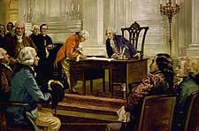
By 1787, something had to be done. Delegates from the 13 states met in Philadelphia. Many wanted a new national government. It had to be strong enough to hold together the new nation, but it could not be too strong. It must not take away their freedom.
Over the summer, the delegates wrote a new plan for government: the Constitution. The delegates signed the Constitution on September 17, 1787. The Constitution would be the “law of the land,” but first it had to be approved by nine of the 13 states. The signers knew that approval of the Constitution would not be easy since many people opposed it. People in every state talked about one question: Should they accept the new Constitution?
Hamilton, Jay, and Madison
Just days after the new Constitution was signed, many New York newspapers began to attack it. They said that the new Constitution took away the rights Americans had won in the Revolution.
Alexander Hamilton was a lawyer from New York who had helped write the Constitution, and he was the only delegate from New York who signed it. The others had refused to sign, because they agreed with the critics in the newspapers. Hamilton feared that New York might not approve the Constitution and decided to write essays arguing with the critics.
Hamilton wanted a strong central government. He even favored one stronger than the one outlined in the new Constitution. But Hamilton supported the Constitution as a great improvement over the Articles of Confederation. In October 1787, he published his first essay defending the Constitution. He signed it using the Roman name “Publius.” (Political writers then often used pen names.) Hamilton soon asked two other men, James Madison and John Jay, to write articles. They also used the name “Publius.”
James Madison is sometimes called the Father of the Constitution. He played a major role at the Constitutional Convention. As a delegate from Virginia, he kept notes of the talks and wrote much of the Constitution. John Jay had helped negotiate the Treaty of Paris, which ended the Revolutionary War, but had not helped write the Constitution. He was serving as secretary of foreign affairs, a diplomatic office, when Hamilton asked him to help write the essays.
Hamilton, Madison, and Jay wrote 85 essays for the New York papers. The essays drew much praise, and many people outside of New York wanted to read them. One New York newspaper printed the essays as a book (in two volumes) called The Federalist. By this time, most people knew that “Publius” was actually Hamilton, Jay, and Madison.
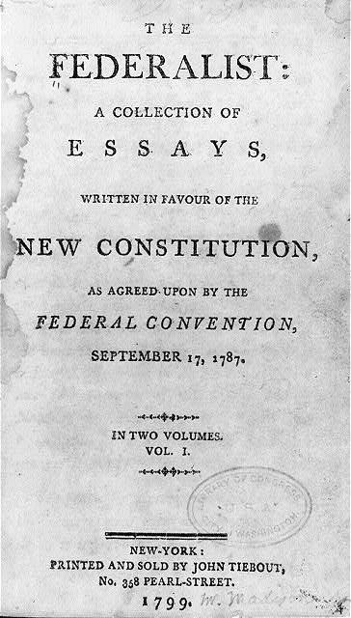
The Federalist was also called the The Federalist Papers. It helped convince New Yorkers that the Constitution was a good model for a new government. Today, The Federalist Papers text helps us understand what the writers of the Constitution had in mind when they drafted that amazing document 200 years ago.
What The Federalist Papers Said
The Federalist Papers text addressed issues about the Constitution. In Federalist Paper, No. 23, Hamilton listed the main goals of government. One was “common defense.” This meant keeping law and order at home and protecting the nation from “external attacks.” Another big goal was to control trade between states and with other nations. A third goal was dealing with “foreign countries.”
In Federalist Paper, No. 51, Madison told why government is needed. “If men were angels, no government would be necessary.” He then explained why government needs checks on it. “If angels were to govern men,” no checks would be needed. “In framing a government which is to be administered by men over men,” he continued, “the great difficulty lies in this: you must first enable the government to control the governed; and in the next place oblige it to control itself.” In other words, government had to have power, but not too much power.
Title page of The Federalist, vol. 1 (N.Y.: John Tiebout, 1799), a collection of the Federalist Papers. (Library of Congress). What do you notice first about this title page? What can you learn from examining this? What do you wonder about?

The Federalist Papers text explained how the Constitution set up such a government. Much of the Federalist Papers explained three basic ideas behind the Constitution:
- The Constitution separates the powers of the national government.
- The Constitution creates a federal form of government.
- The Constitution sets up a republic.

Comparing the Articles of Confederation and Constitution.
The Articles of Confederation set up the first government of the United States. The Constitution was written to replace this government with a new government. The Federalists supported the Constitution. The Anti-Federalists opposed it.
Here is a comparison of the governments set up by the two documents.
 | Articles of Confederation | Constitution
Executive Branch | No executive branch. | President elected by electoral college. Has checks on legislative and judicial branches.
Judicial Branch | No judicial branch. Each state had its own court system. | System of federal courts headed by the U.S. Supreme Court. (Each state still had its own court system.)
Legislative Branch | Congress.  Each state had 1 vote. The Congress elected a president to preside over Congress. | Two houses of Congress:  Senate: Each state has two senators.  House of Representatives: Membership based on the population of the state.
Passing a Law | Nine of the 13 states must vote in favor of it. | A majority in each house must pass it and the president must sign it.
Power over States and Individuals | Had power over states only. Thus it created a federal government. | Had power over states and individuals. Thus it created both a federal and national government.
Amending | To change the Articles, every state had to agree. | Two ways to change the Constitution:  - Passed by b of both houses of Congress and : of the state legislatures.  - Constitutional Convention called by b of state legislatures.
Raising an Army | No power to raise an army. Could only ask states to send soldiers. | Power to raise an army.
Taxing | No power to tax. Could only ask states for tax money. | Power to tax.
Controlling Trade | No power to control trade between the states or with other nations. | Power to control trade.
Bill of Rights | None. | None in original document. The first 10 amendments to the Constitution make up the Bill of Rights.

Separation of Powers
The Constitution puts many checks on government. One is called the separation of powers. Congress, the president, and the courts have separate powers. Congress makes laws, the president carries them out, and the courts say what the laws mean. In Federalist Paper, No. 47, Madison told why the powers of government should be separated. He said: Putting “all powers . . . in the same hands, whether of one, a few, or many, and whether hereditary, self-appointed, or elective, may justly be pronounced the very definition of tyranny.” In other words, giving one person or group all the power will unjustly take away other people’s freedom.

Federalism
Another check on government is federalism. The Constitution lists the powers of the national government and reserves all other powers for the states. This dual system of state and national governments is known as federalism. As Madison explained in Federal Paper, No. 46, the federal system lets state governments, which are closer to the people, meet the “personal interests of the people.” The states also serve to check the power of the federal government.

A Republic
The Federalist Papers text emphasized that the Constitution created a republic. A republic is a representative democracy, which is a system in which people elect those who govern them. A republic relies on the consent of the governed. In Federalist Paper, No. 39, Madison defined a republic as a government that gets its powers from the people and is run “by persons holding their offices . . . for a limited period, or during good behavior.”
Madison went on to point out that the Constitution follows these rules. The people directly elect the members of the House of Representatives and indirectly choose the president and senators. (Under the Constitution, Senators were elected by the state legislatures. The president was elected by the Electoral College.)
The Constitution set the terms for president (four years), senator (six years), and member of Congress (two years). It gave federal judges life terms (as long as they show “good behavior”).
In Federalist Paper, No. 78, Hamilton explained why judges should serve such long terms. He said that the courts must protect the Constitution, and life terms for judges will give them an “independent spirit.” Judges must know that they don’t have to agree with Congress or the president to keep their jobs. “This independence of the judges,” Madison wrote, “is equally requisite to guard the Constitution and the rights of individuals . . . .”
Many thinkers believed that a republic could not work in a large country. They thought it could only work properly in states or cities where people knew the community and could work for the common good. In a large country, they argued, the government is far from the people, and special interests, or factions, would take over.
In Federalist Paper, No. 10, Madison responded that large republics actually prevented special interests from taking over. Madison said that in a large republic, “. . . you take in a greater variety of . . . interests; you make it less probable that a majority . . . will have a common motive to invade the rights of other citizens . . . .” In other words, in a large republic, the special interests balance each other out.
The Federalist Papers text stressed that the Constitution was setting up a government that would preserve freedom. The new government would be strong enough to protect the nation, but it would not be too strong as to take away people’s freedom. Its powers would be limited and checked through federalism and the separation of powers. It also would be a republic, based on the consent of the governed.

The Anti-Federalists
Those opposed to the Constitution were called the Anti-Federalists. They also wrote essays in New York newspapers. They, too, used Roman pen names: “Brutus” and “Cato” and some others.
They made several points.
First, they said that Congress, the president, and the courts would have too much power, more power than the old British government. The British had crushed American freedom. They said the government created by the Constitution would also.
Second, they wanted the states to keep their power. They thought that only small governments, close to the people, could insure freedom. A strong national government would not listen to the people.
Third, they said that the Constitution should have a bill of rights.
This last point struck a chord. Many people wanted a bill of rights. They had just fought a war to be free and did not want the new government to take away their rights.
In Federalist Paper, No. 84, Hamilton said that a bill of rights was not needed. He said the new government would not have the power to abuse people’s rights. He asked: Why say “that things shall not be done which there is no power to do?”

Approval of the Constitution
By June 1788, most states had approved the Constitution. But several states still had not. The two biggest states, New York and Virginia, were still debating. To get these states to approve the Constitution, the Federalists promised that a bill of rights would be added to it. With this promise, the states approved the Constitution.
James Madison was elected to Congress from Virginia. When the first Congress met in 1789, he saw it as his duty to add a bill of rights to the Constitution. He drafted proposed amendments to the Constitution. Congress passed 10 of the amendments, and these amendments are called the Bill of Rights. They list many rights: freedom of speech, freedom of religion, right to a jury trial, and many other rights that Americans today still think are important to a free society.
The Constitution was not perfect. It did not outlaw slavery. This was not done until after the Civil War when the 13th Amendment was added. The Constitution also did not give women the right to vote. This was not done until after World War 1 when the 19th Amendment was adopted.
Over the years, other changes to the Constitution have been made. In 1913, the 17th Amendment let the people of each state, instead of the state legislature, elect senators. In 1951, the 22nd Amendment limited presidents to two terms in office.
In all, only 27 amendments have been added to the Constitution. It created a democratic government that has lasted more than 200 years. The Federalist Papers text helped create this government.

For Discussion and Writing
      - What was the Articles of Confederation? Why did it fail? How did its failure lead to the writing of the Constitution?
- What are the main differences between the Articles of Confederation and the later Constitution in terms of the Executive Branch, Judicial Branch, Legislative Branch, Passing a Law, and Power over States and Individuals (the first five items on the chart)?
- What are the main differences between the Articles of Confederation and the Constitution in terms of Amending, Raising an Army, Taxing, Controlling Trade, and the Bill of Rights (the last five items on the chart)?
- What do you find in The Federalist Papers? Who were the authors and how was their work published?
- What did Hamilton consider three main goals of government? Why did Madison believe government was necessary, and also why it needed checks?
- What were the three basic ideas behind the Constitution expressed in The Federalist Papers? How did the Constitution set up a strong government that preserved freedom?
- Hamilton said that judges need an “independent spirit.” What did he mean? What were the arguments for and against a republic?
- Why did the Anti-Federalists oppose the Constitution? What do you think was their strongest point? Why?
- Why did the Federalists oppose a bill of rights? Do you agree? Explain. How did the Bill of Rights get added to the Constitution? What are some examples of rights that were protected?
- Why do people today think The Federalist Papers text is important? What other changes to the Constitution have been made since the Bill of Rights was added?

Handout B1
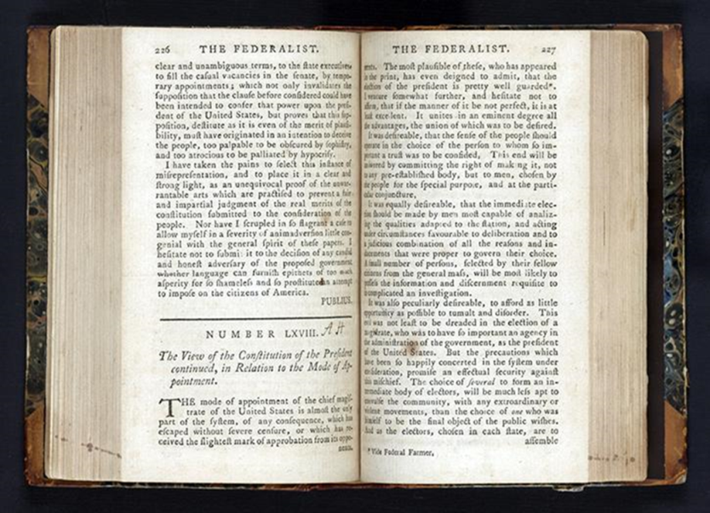
Excerpt of Text of “[Alexander Hamilton]. Number LXVIII.” (Federalist No. 68)

|| Federalist No. 68 ||
The Mode of Electing the President
From the New York Packet
Friday, March 14, 1788.
Author: Alexander Hamilton
To the People of the State of New York:
THE mode of appointment of the Chief Magistrate of the United States is almost the only part of the system, of any consequence, which has escaped without severe censure, or which has received the slightest mark of approbation from its opponents. The most plausible of these, who has appeared in print, has even deigned to admit that the election of the President is pretty well guarded. [1] I venture somewhat further, and hesitate not to affirm, that if the manner of it be not perfect, it is at least excellent. It unites in an eminent degree all the advantages, the union of which was to be wished for.
It was desirable that the sense of the people should operate in the choice of the person to whom so important a trust was to be confided. This end will be answered by committing the right of making it, not to any preestablished body, but to men chosen by the people for the special purpose, and at the particular conjuncture.
It was equally desirable, that the immediate election should be made by men most capable of analyzing the qualities adapted to the station, and acting under circumstances favorable to deliberation, and to a judicious combination of all the reasons and inducements which were proper to govern their choice. A small number of persons, selected by their fellow-citizens from the general mass, will be most likely to possess the information and discernment requisite to such complicated investigations.
It was also peculiarly desirable to afford as little opportunity as possible to tumult and disorder. This evil was not least to be dreaded in the election of a magistrate, who was to have so important an agency in the administration of the government as the President of the United States. But the precautions which have been so happily concerted in the system under consideration, promise an effectual security against this mischief. The choice of SEVERAL, to form an intermediate body of electors, will be much less apt to convulse the community with any extraordinary or violent movements, than the choice of ONE who was himself to be the final object of the public wishes. And as the electors, chosen in each State, are to assemble and vote in the State in which they are chosen, this detached and divided situation will expose them much less to heats and ferments, which might be communicated from them to the people, than if they were all to be convened at one time, in one place.
Source: https://www.congress.gov/resources/display/content/The+Federalist+Papers#TheFederalistPapers-68
Handout B2 (Gerry)

home

Of the 42 delegates who stayed to the end of the Constitutional Convention in Philadelphia in 1787, 39 signed the document. One who did not sign the Constitution of the United States was Elbridge Gerry, a delegate from Massachusetts. A letter written by Gerry to the Massachusetts state legislature appears below. In the letter, Gerry describes why he did not sign the Constitution. What objections did he have to the document? Do you think Gerry was right not to sign the Constitution? Why or why not?

Gentlemen : I have the honor to enclose, pursuant to my commission, the Constitution proposed by the Federal Convention.
To this system I gave my dissent, and shall submit my objections to the honorable legislature.
It was painful for me, on a subject of such national importance, to differ from the respectable members who signed the Constitution; but conceiving, as I did, that the liberties of America were not secured by the system, it was my duty to oppose it.
My principal objections to the plan are, that there is no adequate provision for a representation of the people; that they have no security for the right of election; that some of the powers of the legislature are ambiguous, and others indefinite and dangerous; that the executive is blended with, and will have an undue influence over, the legislature; that the judicial department will be oppressive; that treaties of the highest importance may be formed by the President, with the advice of two thirds of a quorum of the Senate; and that the system is without the security of a bill of rights . These are objections which are not local, but apply equally to all the states.
As the Convention was called for "the sole and express purpose of revising the Articles of Confederation, and reporting to Congress, and the several legislatures, such alterations and provisions as shall render the Federal Constitution adequate to the exigencies of government, and the preservation of the Union," I did not conceive that these powers extend to the formation of the plan proposed; but the Convention being of a different opinion, I acquiesced in it, being fully convinced that, to preserve the Union, an efficient government was indispensably necessary, and that it would be difficult to make proper amendments to the Articles of Confederation.
The Constitution proposed has few, if any, federal features, but is rather a system of national government. Nevertheless, in many respects, I think it has great merit, and, by proper amendments, may be adapted to the "exigencies of government, and preservation of liberty."
The question on this plan involves others of the highest importance: 1. Whether there shall be a dissolution of the federal government; 2. Whether the several state governments shall be so altered as in effect to be dissolved; 3. Whether, in lieu of the federal and state governments, the national Constitution now proposed shall be substituted without amendment. Never, perhaps, were a people called on to decide a question of greater magnitude. Should the citizens of America adopt the plan as it now stands, their liberties may be lost; or should they reject it altogether, anarchy may ensue. It is evident, therefore, that they should not be precipitate in their decisions; that the subject should be well understood;--lest they should refuse to support the government after having hastily accepted it.
If those who are in favor of the Constitution, as well as those who are against it, should preserve moderation, their discussions may afford much information, and finally direct to a happy issue.
It may be urged by some, that an implicit confidence should be placed in the Convention; but, however respectable the members may be who signed the Constitution, it must be admitted that a free people are the proper guardians of their rights and liberties; that the greatest men may err, and that their errors are sometimes of the greatest magnitude.
Others may suppose that the Constitution may be safely adopted, because therein provision is made to amend it. But cannot this object be better attained before a ratification than after it? And should a free people adopt a form of government under conviction that it wants amendment?
And some may conceive that, if the plan is not accepted by the people, they will not unite in another. But surely, while they have the power to amend, they are not under the necessity of rejecting it.
I have been detained here longer than I expected, but shall leave this place in a day or two for Massachusetts, and on my arrival shall submit the reasons (if required by the legislature) on which my objections are grounded.
I shall only add that, as the welfare of the Union requires a better Constitution than the Confederation, I shall think it my duty, as a citizen of Massachusetts, to support that which shall be finally adopted, sincerely hoping it will secure the liberty and happiness of America.
I have the honor to be, gentlemen, with the highest respect for the honorable legislature and yourselves, your most obedient and very humble servant,
E. GERRY.
To the Hon . Samuel Adams , Esq., President of the Senate, and the Hon . James Warren , Esq., Speaker of the House of Representatives, of Massachusetts.

Handout C1

Source Analysis Questions
Source: “[Alexander Hamilton]. Number LXVIII.”

A. Read through the entire text first.
B. Complete the Source Analysis Questions.
C. Be prepared to contribute your ideas to class discussion.

(Use supporting quotes in your answers to questions 3, 4, and 5)

1. What kind of document is this?

2. Who created it? Where was it created? When was it created? What was the purpose of this text?

3. How does the author propose to keep “the sense of the people” in the election of the president of the United States?

4. Why does the author believe a “small number of persons” or “electors” should choose the president in national elections?

5. Why does the author believe that “tumult and disorder” will be avoided under the elector system of choosing a president?

6. What else can you learn from examining this text?

7. What further questions do you have after examining the text? (Who? What? When? Where? Why? How?)

Handout C2

Source Analysis Questions
Source: “[Elbridge Gerry] Reasons for Not Signing the Federal Constitution

A. Read through the entire text first.
B. Complete the Source Analysis Questions.
C. Be prepared to contribute your ideas to class discussion.

(Use supporting quotes in your answers to questions 3, 4, and 5)

1. What kind of document is this?

2. Who created it? Where was it created? When was it created? What was the purpose of this text?

3. What are the author’s “principal objections to the plan” for a new Constitution? Why did he feel it was his “duty to oppose it”?

4. Why did the author decide to participate in the Constitutional Convention?

5. What other 3 questions about the plan does the author identify as “of the highest importance”? What does he see as possible dangers both to adopting and not adopting the plan?

6. What else can you learn from examining this text?

7. What further questions do you have after examining the text? (Who? What? When? Where? Why? How?)
Handout D (Optional/Extended Activity---Debate)
Short Biographies
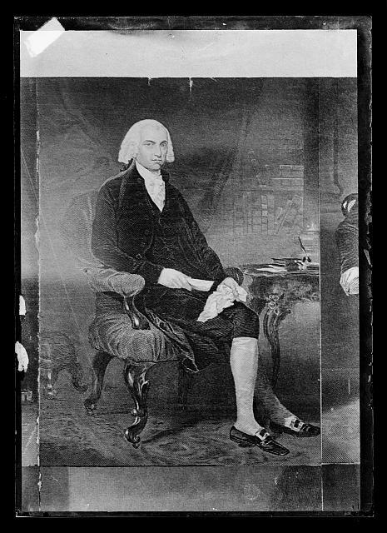
James Madison (1751–1836), Federalist
The oldest of 10 children, Madison was born and grew up in Virginia. A great student, he went to the College of New Jersey (now called Princeton University). He returned home, unsure of what to do with his life. As the Revolutionary War came near, he joined the patriot cause. As a young man, he held several elected offices. One was being a member of Congress under the Articles of Confederation. Madison grew frustrated with Congress’ lack of power. For example, Congress did not have power to raise taxes to pay the Army. Madison believed that the nation needed a strong central government. At the Constitutional Convention, his ideas were so important that many today consider him the “Father of the Constitution.” After the convention, Madison wrote many of the essays in The Federalist Papers arguing in favor of the Constitution. Madison believed the Constitution would uphold freedom because it created a republic with checks and balances on its power. He did not think a bill of rights was needed. The Constitution had limited power.
Madison favored religious freedom and the separation of church and state. Before the revolution, he spoke out against people being put in jail for their beliefs. He helped draft Jefferson’s Bill for Religious Freedom in Virginia. He worked to defeat Patrick Henry’s bill in Virginia that would have given tax money to “teachers of the Christian religion.” He thought government should neither support nor oppose religion.
When the Constitution was adopted, Madison was elected to the first Congress. He knew that a bill of rights had been promised. So he wrote one and pushed Congress to pass it. Congress passed most of Madison’s proposals. They stand today as the Bill of Rights, the first 10 amendments to the Constitution.
Madison later served as secretary of state and as the fourth U.S. president.
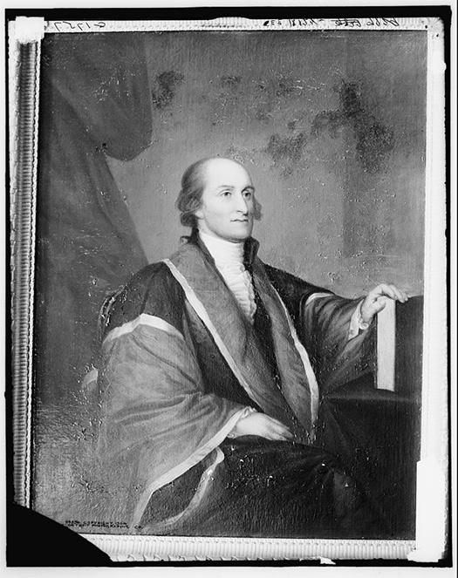
John Jay (1745–1829), Federalist
The sixth of 10 children, Jay was born and raised in New York. As a boy, he was taught by private tutors. Then he went to King’s College (now called Columbia University). He started work as a lawyer and did well. Although he backed the patriot cause, he at first did not favor breaking from England. But once the revolution began, he strongly supported it. He was elected to the Continental Congress. Sent to Paris, he helped write the peace treaty of 1783, which ended the Revolutionary War. Under the Articles of Confederation, Jay served as Congress’ secretary for foreign affairs. In this post, Jay met and negotiated with foreign leaders. He grew frustrated, however, by the limited power given Congress under the Articles of Confederation. He cited many examples of this limited power. One was that Congress had power to make treaties with other nations, but it didn’t have the power to keep the promises it made in the treaties. Another was that Congress had the power to borrow money, but not to raise money to pay back the debt. He believed the United States needed a stronger central government. He did not go to the Constitutional Convention, but he strongly supported the Constitution. He did not think a bill of rights was needed.
He later served as the first chief justice of the U.S. Supreme Court and was elected governor of New York.
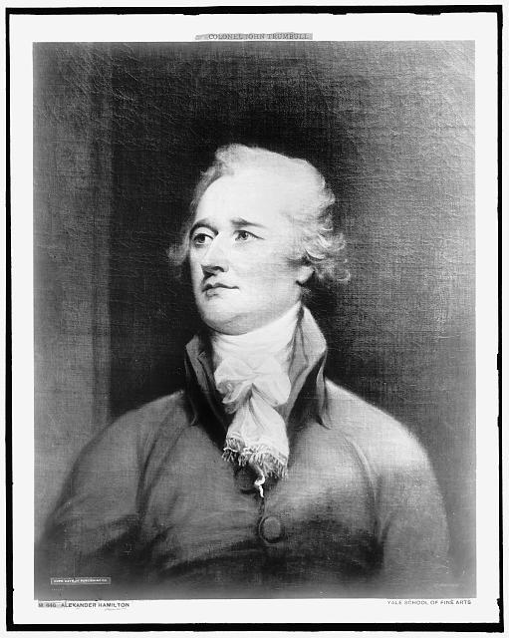
Alexander Hamilton (c. 1757–1804), Federalist
Hamilton was born in the West Indies. When he was 8, his father left the family. To help support the family, Hamilton went to work. Four years later, his mother died. He went to live with relatives. His family and friends saw that Hamilton was very smart. They sent him to New Jersey to study. He later entered King’s College (now called Columbia University) in New York. When the Revolutionary War broke out, he joined the Army. General George Washington noticed his bravery and brainpower. He asked him to serve as his aide. When the war ended, Hamilton returned to New York and became a lawyer. He was elected to the Continental Congress. He thought the government created by the Articles of Confederation was too weak. He believed it was causing the country to fall apart. For example, the war had caused the government to go into debt. But the Congress could not pay off the debt, because it had no power to tax. When the Constitutional Convention was held, Hamilton went as a delegate from New York. Hamilton believed the United States should have a very strong central government. He thought the president and senators should be elected for life. He wanted the president to select state governors. He thought Congress should make all the laws for the country. The delegates ignored his ideas. Hamilton would have liked a stronger central government than the one created by the Constitution. But he liked the Constitution much better than the Articles of Confederation. When he returned to New York, he started writing newspaper articles in favor of the Constitution. He got James Madison and John Jay to help him. These articles became The Federalist Papers.
Hamilton went on to be the first secretary of the treasury under President Washington. He was killed in a duel in 1804.

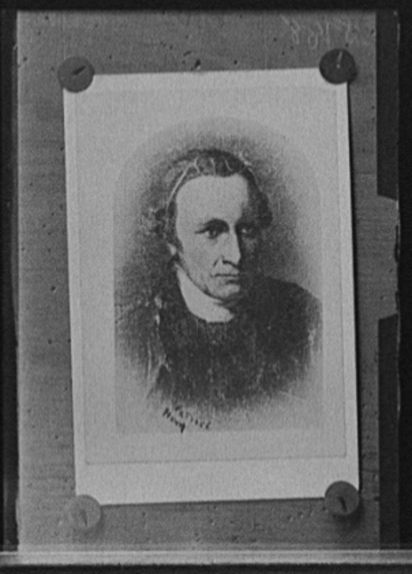
Patrick Henry (1736–1799), Anti-Federalist
Henry was born in Virginia and home-schooled. As a young man, he struggled. Twice, he opened stores. But he lost money and went out of business. He tried farming, but made no money. He decided to study law and started a practice. At this, he succeeded. He was a great speaker and could rouse people to his side. Drawn to the patriot cause, he was elected to the Virginia colonial legislature.
Later, he went to Congress. He made many speeches that made him famous. After a speech denouncing the king, some legislators yelled, “Treason!” Henry shouted back, “If this be treason, make the most of it!” When the Revolutionary War began, he made a speech that ended with the now famous words, “I know not what course others may take, but as for me, give me liberty or give me death.” He was elected governor of Virginia during and after the war.
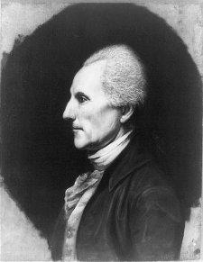
Henry was invited to the Constitutional Convention, but did not go. He spoke out strongly against the Constitution. He said it created too strong a central government. He stated that the best government was one that was close to the people and that could listen to them. He declared that the Constitution would take away the power of the states and the rights of the people. He was outraged that it did not have a bill of rights.
Richard Henry Lee (1732–1794), Anti-Federalist
Born in Virginia to a rich family, Lee was home-schooled. Then he was sent to school in England. After returning home, he was elected to the Virginia legislature. He spoke out against slavery. Then as British rule grew harsher, he spoke out against British abuses. He opposed the Stamp Act and Townshend Acts. As war drew near, he became a leader in Congress favoring independence. He retired from Congress due to ill health. But after he recovered, he returned to elected office. He was a member of Congress under the Articles of Confederation. He helped pass the Northwest Ordinance, one of the most important things done by the Confederation Congress. The Northwest Ordinance set up a system for governing the Northwest Territory.
This land eventually became the states of Ohio, Indiana, Illinois, Michigan, and Wisconsin and part of the state of Minnesota. The ordinance outlined how parts of the territory could become states.
Lee opposed the Constitution. He thought the Confederation Congress worked. He did not want another strong government. He had opposed British abuses. He feared another strong government would also misrule. He thought it was a disaster that the Constitution did not have a bill of rights.

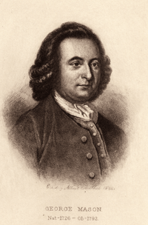
George Mason (1725–1792), Anti-Federalist
Mason was in born in Virginia into a family of rich landholders. His father died when he was 10. His uncle took over as his guardian and taught him law. When he grew up, he became one of the richest planters in Virginia. Elected to the colonial Virginia legislature in 1759, he grew active in the patriot cause. When Virginia drew up its state constitution in 1776, Mason drafted its Declaration of Rights. The beginning of this declaration influenced the Declaration. And most of all, he demanded a bill of rights. When the delegates failed to include a bill of rights, Mason refused to sign the Constitution. He believed the Constitution would lead to either a monarchy or the rule by a select few.

Handout E (Optional/Extended Activity)

Debate: Federalist vs. Anti-Federalist

Imagine that it is 1788. The Federalists and Anti-Federalists are holding a debate on the Constitution. You are going to play the role of a famous Federalist or Anti-Federalist.
- Your teacher will divide the class into six groups.
- Your teacher will assign your group one of the Federalists or Anti-Federalists on Handout D. Write down the name of the person you are assigned:
- You must be able to discuss your person’s opinions on these questions:
• Do you think it is important that the United States have a strong central government? Why or why not?
• Do you think the Constitution should have a bill of rights? Why or why not?
• Do you favor or oppose the Constitution? Why?
- Prepare for the debate. Do the following:
• Read your person’s biography. Think how your person would answer the questions.
• Read the biographies of other people. Be prepared to respond to any points that they may make.
• Reread the article The Federalist Papers and take a close look at the chart “Comparing the Articles of Confederation and Constitution.” This material will help your preparation.
• Prepare your answers.
• Make an introduction for your person. (You will need to know what the person had accomplished by 1788 and why he was an important person.)
• If your teacher permits, find more information. You can do this in two ways:
A. Go to the library. Look in the encyclopedia for general information. Then, look for books and periodicals with more information. A library will usually have computers that allow you to search the library’s database and card catalog. Reference librarians also can help you locate books and periodicals.
B. On the Internet, go to the Constitutional Rights Foundation web site (www.crf-usa.org) and click on Links. Then, click on Project History Links. Click on The Federalist Papers. Your person is listed with links to a lot of information.
5. The class will meet and hold a debate on the Constitution. You will first introduce your person and then role-play him in the debate.

Handout F1 (Hamilton to Washington Letter)
https://memory.loc.gov/cgi-bin/query/D?hlaw:1:./temp/~ammem_t4Qn::#0030058

Farrand's Records --LIV. Alexander Hamilton to George Washington.²

The Records of the Federal Convention of 1787 [Farrand's Records, Volume 3]
LIV. Alexander Hamilton to George Washington.²
[Note 2: 2 Documentary History of the Constitution, IV, 226--227.]
July 3d. 87
In my passage through the Jerseys and since my arrival here I have taken particular pains to discover the public sentiment and I am more and more convinced that this is the critical opportunity for establishing the prosperity of this country on a solid foundation -- I have conversed with men of information not only of this City but from different parts of the state; and they agree that there has been an astonishing revolution for the better in the minds of the people. The prevailing apprehension among thinking men is, that the Convention, from a fear of shocking the popular opinion, will not go far enough -- They seem to be convinced that a strong well mounted government will better suit the popular palate than one of a different complexion. Men in office are indeed taking all possible pains to give an unfavourable impression of the Convention; but the current seems to be running strongly the other way.
A plain but sensible man, in a conversation I had with him yesterday, expressed himself nearly in this manner -- The people begin to be convinced that their "excellent form of government" as they have been used to call it, will not answer their purpose; and that they must substitute something not very remote from that which they have lately quitted.
These appearances though they will not warrant a conclusion that the people are yet ripe for such a plan as I advocate, yet serve

Page 54 |
to prove that there is no reason to despair of their adopting one equally energetic, if the Convention should think proper to propose it. They serve to prove that we ought not to allow too much weight to objections drawn from the supposed repugnancy of the people to an efficient constitution -- I confess I am more and more inclined to believe that former habits of thinking are regaining their influence with more rapidity than is generally imagined.
Not having compared ideas with you, Sir, I cannot judge how far our sentiments agree; but as I persuade myself the genuineness of my representations will receive credit with you, my anxiety for the event of the deliberations of the Convention induces me to make this communication of what appears to be the tendency of the public mind. ...I own to you Sir that I am seriously and deeply distressed at the aspect of the Councils which prevailed when I left Philadelphia--I fear that we shall let slip the golden opportunity of rescuing the American empire from disunion anarchy and misery -- No motley or feeble measure can answer the end or will finally receive the public support. Decision is true wisdom and will be not less reputable to the Convention than salutary to the community.
I shall of necessity remain here ten or twelve days; if I have reason to believe that my attendance at Philadelphia will not be mere waste of time, I shall after that period rejoin the Convention.

Bibliographic Information from the Library of Congress

Farrand's Records

The Records of the Federal Convention of 1787
One of the great scholarly works of the early twentieth century was Max Farrand's The Records of the Federal Convention of 1787. Published in 1911, Farrand's work gathered the documentary records of the Constitutional Convention into four volumes--three of which are included in this online collection--containing the materials necessary to study the workings of the Constitutional Convention. According to Farrand's introduction, at the close of the convention, the secretary, William Jackson, delivered all the materials to the president of the convention, George Washington, who turned these papers over to the Department of State in 1796. In 1818, Congress ordered that the records be printed, which was done under the supervision of the Secretary of State John Q. Adams, in 1819.
Farrand's Records remains the single best source for discussions of the Constitutional Convention. The notes taken at that time by James Madison, and later revised by him, form the largest single block of material other than the official proceedings. The three volumes also includes notes and letters by many other participants, as well as the various constitutional plans proposed during the convention.

Handout F2 (Madison to Washington Letter) American Memory: century of lawmaking, letters of delegates to congress Vol 24 Nov 6 1786 – Feb 29 1788
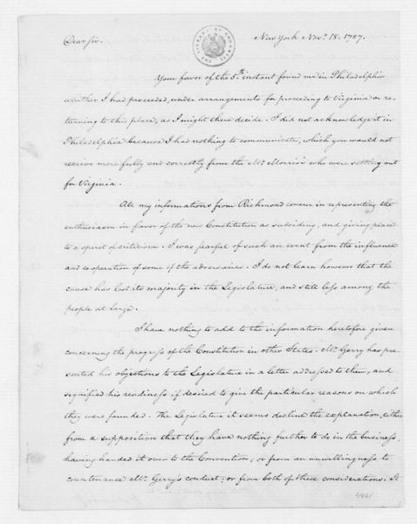
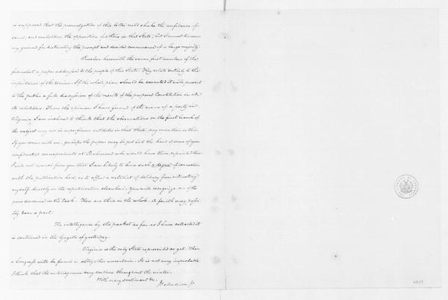

Text of Letter:
Dear Sir
New York Novr. 18. 1787.
Your favor of the 5th instant(1) found me in Philada. whither I had proceeded, under arrangements for proceeding to Virginia or returning to this place, as I might there decide. I did not acknowledge it in Philada. because I had nothing to communicate, which you would not receive more fully and correctly from the Mr. Morris's who were setting out for Virginia.(2)
All my informations from Richmond concur in representing the enthusiasm in favor of the new Constitution as subsiding, and giving place to a spirit of criticism. I was fearful of such an event from the influence and co-operation of some of the adversaries. I do not learn however that the cause has lost its majority in the Legislature, and still less among the people at large.
I have nothing to add to the information heretofore given concerning the progress of the Constitution in other States. Mr. Gerry has presented his objections to the Legislature in a letter addressed to them, and signified his readiness if desired to give the particular reasons on which they were founded. The Legislature it seems decline the explanation, either from a supposition that they have nothing further to do in the business, having handed it over to the Convention; or from an unwillingness to countenance Mr. Gerry's conduct; or from both these considerations. It is supposed that the promulgation of this letter will shake the confidence of some, and embolden the opposition of others in that State; but I cannot discover any ground for distrusting the prompt & decided concurrence of a large majority.(3)
I inclose herewith the 7 first numbers of the federalist, a paper addressed to the people of this State. They relate entirely to the importance of the Union. If the whole plan should be executed, it will present to the public a full discussion of the merits of the proposed Constitution in all its relations. From the opinion I have formed of the views of a party in Virginia I am inclined to think that the observations on the first branch of the subject may not be superfluous antidotes in that State, any more than in this. If you concur with me, perhaps the papers may be put into the hand of some of your confidential correspondents at Richmond who would have them reprinted there. I will not conceal from you that I am likely to have such a degree of connection with the publication here, as to afford a restraint of delicacy from interesting myself directly in the republication elsewhere. You will recognize one of the pens concerned in the task. There are three in the whole. A fourth may possibly bear a part.(4)
The intelligence by the packet as far as I have collected it, is contained in the gazette of yesterday.
Virginia is the only State represented as yet. When a Congress will be formed is altogether uncertain. It is not very improbable I think that the interregnum may continue throughout the winter.
With every sentiment of respect & attachment, I remain dear Sir Yr. Affect. & hble servant, Js. Madison Jr.

Handout G (Objections of the Hon. George Mason)
https://memory.loc.gov/cgi-bin/ampage?collId=lled&fileName=001/lled001.db&recNum=0&itemLink=r?ammem/hlaw:@field(DOCID+@lit(ed0011))%230010001&linkText=1

Elliot's Debates --OBJECTIONS OF THE HON. GEORGE MASON, ONE OF THE DELEGATES FROM VIRGINIA IN THE LATE CONTINENTAL CONVENTION, TO THE PROPOSED FEDERAL CONSTITUTION; ASSIGNED AS HIS REASONS FOR NOT SIGNING THE SAME.

The Debates in the Several State Conventions on the Adoption of the Federal Constitution [Elliot's Debates, Volume 1]
OBJECTIONS OF THE HON. GEORGE MASON, ONE OF THE DELEGATES FROM VIRGINIA IN THE LATE CONTINENTAL CONVENTION, TO THE PROPOSED FEDERAL CONSTITUTION; ASSIGNED AS HIS REASONS FOR NOT SIGNING THE SAME.
[EXTRACTS.]
There is no declaration of rights; and, the laws of the general government being paramount to the laws and constitutions of the several states, the declarations of rights in the separate states are no security. Nor are the people secured even in the enjoyment of the benefit of the common law, which stands here upon no other foundation than its having been adopted by the respective acts forming the constitutions of the several states.
In the House of Representatives there is not the substance, but the shadow only, of representation, which can never produce proper information in the legislature, or inspire confidence in the people. The laws will, therefore, be generally made by men little concerned in, and unacquainted with, their effects and consequences.
The Senate have the power of altering all money bills, and of originating appropriations of money, and the salaries of the officers of their own appointment, in conjunction with the President of the United States, although they are not the representatives of the people, or amenable to them. These, with their other great powers, (viz., their powers in the appointment of ambassadors, and all public officers, in making treaties, and in trying all impeachments;) their influence upon, and connection with, the supreme executive from these causes; their duration of office; and their being a constant existing body, almost continually sitting, joined with their being one complete branch of the legislature,--will destroy any balance in

Page 495 |
the government, and enable them to accomplish what usurpations they please upon the rights and liberties of the people.
The judiciary of the United States is so constructed and extended as to absorb and destroy the judiciaries of the several states; thereby rendering laws as tedious, intricate, and expensive, and justice as unattainable, by a great part of the community, as in England; and enabling the rich to oppress and ruin the poor.
The President of the United States has no constitutional council, (a thing unknown in any safe and regular government.) He will therefore be unsupported by proper information and advice, and will generally be directed by minions and favorites; or he will become a tool to the Senate; or a council of state will grow out of the principal officers of the great departments--the worst and most dangerous of all ingredients for such a council, in a free country; for they may be induced to join in any dangerous or oppressive measures, to shelter themselves, and prevent an inquiry into their own misconduct in office. Whereas, had a constitutional council been formed (as was proposed) of six members, viz., two from the Eastern, two from the Middle, and two from the Southern States, to be appointed by vote of the states in the House of Representatives, with the same duration and rotation of office as the Senate, the executive would always have had safe and proper information and advice: the president of such a council might have acted as Vice-President of the United States, pro tempore, upon any vacancy or disability of the chief magistrate; and long-continued sessions of the Senate would in a great measure have been prevented. From this fatal defect of a constitutional council has arisen the improper power of the Senate in the appointment of the public officers, and the alarming dependence and connection between that branch of the legislature and the supreme executive. Hence, also, sprang that unnecessary officer, the Vice-President, who, for want of other employment, is made president of the Senate; thereby dangerously blending the executive and legislative powers, besides always giving to some one of the states an unnecessary and unjust preëminence over the others.
The President of the United States has the unrestrained power of granting pardon for treason; which may be sometimes exercised to screen from punishment those whom he had secretly instigated to commit the crime, and thereby prevent a discovery of his own guilt. By declaring all treaties supreme laws of the land, the executive and the Senate have, in many cases, an exclusive power of legislation, which might have been avoided, by proper distinctions with respect to treaties, and requiring the assent of the House of Representatives, where it could be done with safety.
By requiring only a majority to make all commercial and navigation laws, the five Southern States (whose produce and circumstances are totally different from those of the eight Northern and Eastern States) will be ruined; for such rigid and premature regulations may be made, as will enable the merchants of the Northern and Eastern States not only to demand an exorbitant freight, but to monopolize the purchase of the commodities, at their own price, for many years, to the great injury of the landed interest, and the impoverishment of the people; and the danger is the greater, as the gain on one side will be in proportion to the loss on the other. Whereas, requiring two thirds of the members present in both houses, would have produced mutual moderation, promoted the general interest, and removed an insuperable objection to the adoption of the government.

Page 496 |
Under their own construction of the general clause at the end of the enumerated powers, the Congress may grant monopolies in trade and commerce, constitute new crimes, inflict unusual and severe punishments, and extend their power as far as they shall think proper; so that the state legislatures have no security for the powers now presumed to remain to them, or the people for their rights. There is no declaration of any kind for preserving the liberty of the press, the trial by jury in civil cases, nor against the danger of standing armies in time of peace.
The state legislatures are restrained from laying export duties on their own produce; the general legislature is restrained from prohibiting the further importation of slaves for twenty-odd years, though such importations render the United States weaker, more vulnerable, and less capable of defence. Both the general legislature and the state legislatures are expressly prohibited making ex post facto laws, though there never was, nor can be, a legislature but must and will make such laws, when necessity and the public safety require them, which will hereafter be a breach of all the constitutions in the Union, and afford precedents for other innovations.
This government will commence in a moderate aristocracy: it is at present impossible to foresee whether it will, in its operation, produce a monarchy or a corrupt oppressive aristocracy; it will most probably vibrate some years between the two, and then terminate in the one or the other.
GEO. MASON

