Sparta or Athens?

Pronunciation Key

Aeschylus (ESS kuh lus)
Aristophanes (air riss TOFF uh neez)
Dionysus (DIE uh nie sus)
ephors (EFF ors)
Euripides (you RIP uh deez)
Macedon (MASS I don)
Messenians (mess SEN ee uns)
Peloponnesian (pell uh puh NEE zhun)
Sophocles SOFF uh cleez)
Syracuse (SEER uh kyooz)
Thucydides (thew SID id eez)

Introduction
2500 years ago, two totally different city-states dominated Greece. Athens was an open society, and Sparta was a closed one. Athens was democratic, and Sparta was ruled by a select few. The differences were many.

In 431 BCE a war broke out between Athens and Sparta. It was called the Peloponnesian War. This is because Sparta was located on the Peloponnesian Peninsula. If you look at a map of Greece, you will see that the southern part of Greece is attached by a small strip of land. This southern part is called the Peloponnesian Peninsula.

Sparta
Sparta began as a city-state of farmers. As the population grew, Spartans needed more land to farm. To get more, they invaded their neighbors, the Messenians. After a long war, they finally conquered the rich land of Messenia in 715 and made the Messenians their slaves. The Messenians outnumbered the Spartans by 10–1. Treated brutally, the Messenians rose in revolt in 650. It took almost 30 years for the Spartans to put down the revolt.

The revolt changed Sparta forever. Spartans felt that they had to control the Messenians. They saw only one way to do this: They built a strong army, which every male Spartan had to join.

The training lasted almost a lifetime. At birth, unfit babies were left to die. At age 7, boys left home and lived in barracks. They underwent training to make them strong and fearless. They made their own clothes and prepared their own meals. They learned how to fend for themselves.

At age 20, they went in the army. For the next 10 years, they remained in barracks as soldiers. They had to get married at 20, but did not live with their wives until age 30. They remained in the army until 60. Older men inspired the younger men. If duty called, they answered. The Spartan army was the fiercest in Greece.

Since the men’s only job was to fight, this left most of the other work to slaves and women. Slaves (and some free non-Spartans) tended the fields and did chores. Because Spartans feared another slave revolt, they did not allow slaves to go out at night

With the men away for so long, the women took charge. As in other Greek city-states, they could not vote or hold office. But they could own land and even go to court. Women owned about one-third of Spartan land. They married older (age 18) than other Greeks. They were known for standing up to their husbands. A famous Greek writer said that “the men of Sparta always obeyed their wives.”

Other Greeks thought Spartan women were shameless. They went out in public, talked with other people, and did not cover their legs. They exercised hard and competed in sports.

Like their husbands, they devoted their lives to Sparta. They wore no jewelry or fancy clothes. They married to have children who would fight for Sparta. It was said that Spartan mothers had a simple message when their sons left for war: “Come home with your shield or upon it.” In other words, return with the army alive or be killed in battle.

Life in Sparta was tough and dull. Even the food tended to be the same day after day. One outsider after tasting Spartan food said, “Now I know why Spartans don’t fear death.”

The government of Sparta consisted of a Council of 30. The council had 28 elders, who served for life, and two kings. The kings led the army. A citizen assembly elected five leaders, called “ephors,” each year. The ephors had total power during their time in office. They could even arrest the kings or elders.

Athens
Athens, was different in almost every way. Spartans did as they were told. Athenians loved their freedom. Sparta was ruled by a select few. Athenians were their own rulers. They debated and voted on laws in the Assembly.

In their democracy, Athenians had duties. They had to obey the laws, serve in the military, help run the city, pay taxes, and serve on juries. A jury consisted of 500 or more citizens. If an Athenian broke the law or failed to live up to his duties as a citizen, he could be ostracized. This meant that he was forced to leave Athens for 10 years.

The land around Athens was difficult to farm. Athenians grew olive trees and grapes, but had to import food from other places. They built a trading society, selling olives, grapes, wine, pottery, and other goods. Athenians were known as fine craftsmen and artisans.

The city of Athens impressed everyone. Its buildings and statues are still admired today.

Homes of the rich had courtyards and large rooms. Most people, however, lived in simple homes. Men spent most of the daylight hours outside the home. They worked. They went to the marketplace. They hung out in the streets. They played sports and talked at the gymnasium. They went to the theater and saw plays. When it got dark, they went home to eat and sleep.

Women were expected to stay at home and do housework. They cleaned, cooked, and wove cloth. When a husband had guests, the wife was supposed to disappear into another part of the house. If women ventured out of the house, they covered themselves and wore veils to hide their faces. Rich women seldom left the house. Poorer women had to work outside the home.
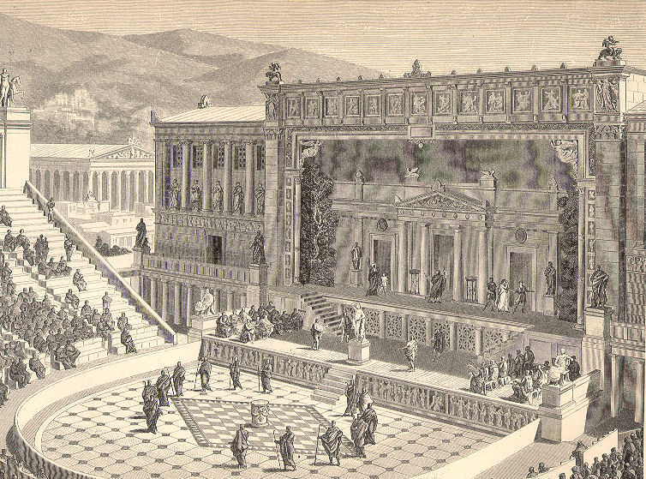
Like most of the ancient world, Athens had slaves, who had been captured in wars. About 100,000 men and women slaves made up about a third of the population. Almost every home had at least one slave. The rich might have 50. Even so, other Greeks complained that Athenians treated their slaves as equals. This was not true, but they did treat them better than the Spartans treated their slaves.

Every year, Athenians held many festivals and contests. The rich paid for their cost. One festival honored Dionysus, the god of wine and drinking. Among other merrymaking at this festival, Athenians watched plays and judged which was the best tragedy and comedy. The Theater of Dionysus held 17,000 people. The performers wore large masks and a chorus of actors spoke many lines.

As a trading city, Athens sent its men to sea. To protect its ships, it built a navy. In time, it developed into the greatest naval power in Greece. It slowly gained control over other city-states.

For Discussion

1. Which city-state, Athens or Sparta, do you think was most likely to win the Peloponnesian War?

2. Which city-state had the best government?

Graphic: Map. Used with permission. http://i0.wp.com/www.gettingaround.net/images/map-greece.jpg

Graphic: Theater of Dionysus. https://upload.wikimedia.org/wikipedia/commons/2/2e/DionysiusTheater.jpg

