The 14th Amendment and Due Process
The 14th Amendment to the United States Constitution
Section 1. No State shall make or enforce any law which shall abridge the privileges or immunities of citizens of the United States; nor shall any State deprive any person of life, liberty, or property, without due process of law; nor deny to any person within its jurisdiction the equal protection of the laws.
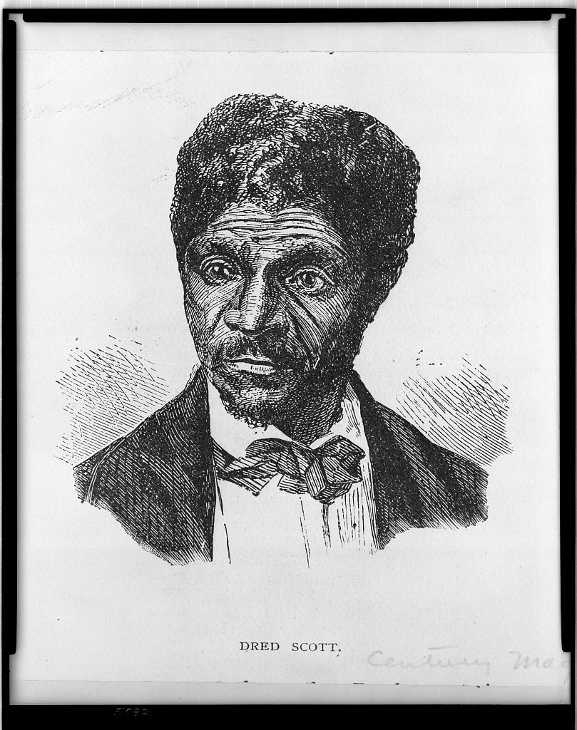
Within months of the end of the Civil War, former rebellious Confederate states began passing Black Codes. These laws were designed to restrict the civil rights of recently freed African Americans. Though the 13th Amendment had ended slavery, it did not specifically assure the rights of citizenship. Congress soon passed a Civil Rights Act to assure equal civic participation and protection for black people. But President Andrew Johnson vetoed it. He believed that Congress lacked the constitutional authority to enact the law. Congress overrode the veto, but a new constitutional amendment was needed to make sure that civil rights legislation would be constitutional.
This was the 14th Amendment. To rejoin the Union, all rebel Southern states had to ratify the new amendment. Declared adopted on July 28, 1868, the amendment nullified (voided) the Supreme Court’s decision in Dred Scott which denied citizenship for black Americans. It also provided a constitutional basis for civil rights legislation. Ultimately the new amendment changed our constitution.
Dred Scott (Library of Congress)
The Constitution, in its original form, served only as a restriction on the power of the federal government. The rights and protections against government power in the Bill of Rights did not apply to the actions of state governments. Protections against state power depended on each state’s constitutions and laws. What rights and protections a person had depended on in which state a person lived.
The 14th Amendment contains the due process clause. It forbids any state from depriving “any person … life, liberty, or property without due process of law.” And the due process clause applies to all “persons,” not just citizens.
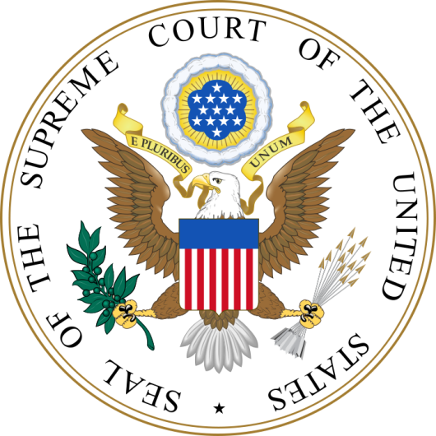
It would fall to the United States Supreme Court to determine the meaning and scope of the 14th Amendment’s due process clause. Beginning in in the late 19th century, the Court developed its “incorporation doctrine.” This meant that the Court would decide on a case-by-case basis which rights and protections from the Bill of Rights were fundamental. Those that the Court decided were fundamental would be applied to the states through the 14th Amendment’s due process clause. This meant that all people in the United States would be protected against state laws and actions that violated fundamental rights. Today, most of the Bill of Rights applies to states.
Some of the Court’s due process decisions have been controversial. Most Americans agree that a person accused of a crime has fundamental rights to an attorney and a fair trial. But some do not agree that owning a gun or same-sex marriage should be constitutional.
One thing is clear. Supreme Court interpretations of the 14th Amendment’s due process clause will continue to change the meaning of the Constitution and our rights into the future.
For Discussion:
- Was it fair to require the former Confederate states to ratify the 14th Amendment before they could rejoin the United States? Why or why not?
- How did the 14th Amendment’s due process clause change the Constitution? Were these changes for the better or worse? Explain your answer.

Image (pg. 2): https://upload.wikimedia.org/wikipedia/commons/thumb/f/f3/Seal_of_the_United_States_Supreme_Court.svg/720px-Seal_of_the_United_States_Supreme_Court.svg.png

